

**EGE UNIVERSITY**

**COMPUTER ENGINEERING**

**SOFTWARE ENGINEERING**

**Term Project:**

PTRFS, Requirements (Analysis) Report / 19.11.2018

**DEVELOPERS:**

Alper Soydan, 05140000697

Burak Kavruk, 05140000610

Mahmut Aslan, 05140000693

Yetkin Sütcü, 05140000626

**Content**

Introduction……………………………………………………………………………….3

Principal Viewpoints of the System……………………………………………...3

Viewpoint Hierarchy Diagram……………………………………………………..3

Requirements of Each Viewpoints……………………………………………….4

Functional Requirements…………………………………………………………....5

Non-Functional Requirements…………………………………………………….5

Domain Requirements………………………………………………………………...5

Volatile Requirements………………………………………………………………...5

Enduring Requirements……………………………………………………………...5

Requirements Interview with Domain Experts…………………………….6

Requirements Prioritization and Negotiation………………………………7

Requirements Traceability Matrix……………………………………………….7

Fully Dressed Use Cases of Main Scenarios…………………………………..8-11

Domain Model as a UML Class Diagram………………………………………..12

**1. Introduction**

Rapidly developing technologies and trying to keep pace with these developments in every field, human beings are constantly renewing their works in order to provide maximum benefit from the developments in transportation area. At this point, it is essential to create a special system that regulates information flow and communication about the transport in the city where people live.

This study aims to inform how people living in any city can go from one point to another by means of existing means of public transport in that city.

**2. Identification of Viewpoints**

**a. Principal Viewpoints of the System:**

Interactor Viewpoints: Each person that uses public transport, Application Database

Indirect Viewpoints: Ministry of Transport and Infrastructure, Provincial/District Municipalities

Domain Viewpoints: Google Map API, GPS, Internet Communication

**b. Viewpoint Hierarchy Diagram:**

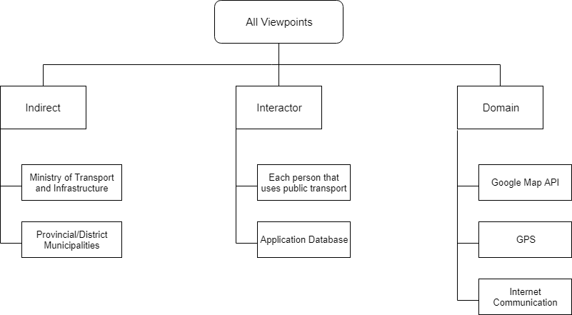

**c. Requirements of Each Viewpoints:**

Interactor Viewpoints

1. Each person that uses public transport:

- They informs the instant location and the point to go, waits for the application to return.

- They can take the departure and arrival times of the any transportation vehicles they want to use.

2. Application Database:

- It returns the optimum means of public transport and stations to the user according to the location information.

- It receives information about new roads and means of public transport to relevant cities and updates the database.

Indirect Viewpoints

1. Ministry of Transport and Infrastructure:

- Gives information about new roads to any city in the application database.

2. Provincial/District Municipalities:

- Provides information about the new means of public transport which are in operation in any city in the application database.

Domain Viewpoints

1. Google Map API:

- Provides data flow for the application.

- Shows the location information of the stations (bus stops, etc.)

2. GPS:

- Gets users’ location information.

3. Internet Communication:

- Controls the internet connection that required for GPS and Google Map API.

**3. Requirements Definition (considering functionality)**

**a. Functional Requirements:**

1. The user should be able to view the voyage times of the means of public transport in the city.

2. The application should be updated according to new incoming information.

3. The user should be able to search with keywords in the application.

4. The user should be able to save the addresses to the system.

**b. Non-Functional Requirements:**

1. A multiple number of users should be able to access the application at the same time.

2. The application interface should be user friendly.

3. Access to the application must be in a steady state.

4. The application's database security must be ensured.

**c. Domain Requirements:**

1. The device to which the application will take place should support GPS and internet connection.

2. Users must accept the Google Map API policy.

3. The application should be able to work on every platform.

**4. Requirements Definition (considering lifetime)**

**a. Volatile Requirements:**

1. User permissions can be changed. (edited by the system administrator)

2. Contact Google for the technical support.

**b. Enduring Requirements:**

1. System data should be backed up every day.

2. System logs must be saved.

**5. Requirements Interview with Domain Experts**

**1. Where do people search which means of public transport to go to where they want to go?**

Answer: Most people uses websites to search how to go where they want to go. Some of them uses mobil applications.

**2. What mean of public transport does people most use?**

Answer: People prefer more buses and minibuses in the city. However, in countries where the railway systems are advanced (such as Japan), it is used very high in the railway.

**3. Would you prefer to see the shortest route rather than alternative routes?**

Answer: Due to traffic, the shortest route may not be the fastest route. Therefore, we think that it is correct to show alternative routes.

**4. Would you like to view the routes that you have already searched for?**

Answer: Absolutely. Because the same route might want to go again after a long time. Therefore, we would like to view the routes we have searched earlier.

**5. Is there any application you know similar to our application? If you use what are the differences from our applications?**

Answer: Yes. It’s called Trafi. It is used for only local places. Difference is you can also use this application between cities.

**6. What kind of innovations do you want to see our application?**

Answer: We would like breaking news about means of public transport. We would like to see if there is any congestion in the traffic and give advice accordingly.

**6. Requirements Prioritization and Negotiation**

a. The system administrator must enter the system authority to update the application.

b. The user must allow the application to access the location in some cases.

**7. Requirements Traceability Matrix**

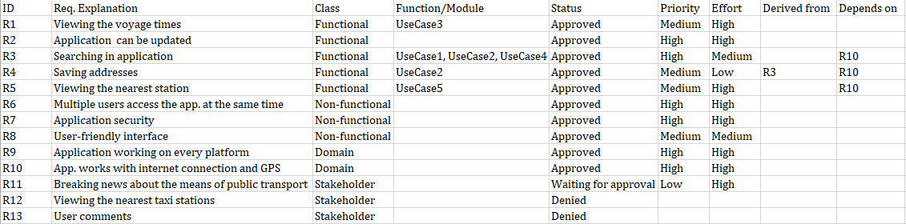

**8. Fully Dressed Use Cases of Main Scenarios**

Use Case1: Move from the user’s location to the selected destination

Scope: Path Transfer Route Finder System Application

Actors: Application System, User

Stakeholders and Interests:

User: The user wants to see the means of public transport that he/she can use from the location to the selected destination.

Pre-Conditions: The user's device must have internet connection and GPS enabled. The user must allow the application to determine the location.

Post Conditions: The means of public transport to the user’s destination must be listed correctly. If the stations (bus stops, etc.) of two consecutive vehicles to be used are within walking distance, the system should also show the shortest path to be walked to reach the next station on the route.

Main Scenario:

1. The user touches the “Get me somewhere” button.

2. The user touches the “Destination” button and enters the destination.

3. First the user touches the “Starting point” button and then touches the “Current location” button.

4. The system returns the recommended means of public transport.

Alternative Scenarios:

3.a) If the application does not have permission to access the location;

1. The application returns an error message and asks for permission to determine the location.

2. The user touches the “Allow” button and the application determines the location.

*.a) If the system crashes at any time;

1. The system administrator is notified.

2. Administrator restarts the system.

UseCase2: Save favorite address to the system

Scope: Path Transfer Route Finder System Application

Actors: Application System, User

Stakeholders and Interests:

User: The user wants to save the favorite addresses in the system.

Pre-Conditions: The user's device must have internet connection and GPS enabled.

Post Conditions: The added addresses must be successfully saved by the system.

Main Scenario:

1. The user touches the “Set your favorite addresses” button.

2. The user enters the address and touches the “Save” button.

3. The system saves the address.

Alternative Scenarios:

*.a) If the system crashes at any time;

1. The system administrator is notified.

2. Administrator restarts the system.

UseCase3: Viewing the voyage times of means of public transport

Scope: Path Transfer Route Finder System Application

Actors: Application System, User

Stakeholders and Interests:

User: The user wants to view the voyage times of the means of public transport in the city.

Pre-Conditions: The user's device must have internet connection and GPS enabled.

Post Conditions: The user has successfuly displayed the voyage times of the means of public transport.

Main Scenario:

1. The user touches the “Voyage Times” button.

2. The user selects the desired means of public transport.

3. The user selects one of the stations (bus stops, etc.) that are displayed on the screen according to the selected means of public transport.

4. The system returns the voyage times of means of public transport passing through the station/bus stops selected by the user.

Alternative Scenarios:

*.a) If the system crashes at any time;

1. The system administrator is notified.

2. Administrator restarts the system.

UseCase4: Listing of city buses and private buses passing through a certain bus stop

Scope: Path Transfer Route Finder System Application

Actors: Application System, User

Stakeholders and Interests:

User: The user wants to see the city buses and private buses passing through the selected bus stop.

Pre-Conditions: The user's device must have internet connection and GPS enabled.

Post Conditions: City buses and private buses passing through the user’s selected bus stop have been successfully listed.

Main Scenario:

1. The user touches the “Bus Stops” button.

2. The user selects one of the bus stops he/she wants to see.

3. The system lists the buses passing by that selected bus stop.

Alternative Scenarios:

*.a) If the system crashes at any time;

1. The system administrator is notified.

2. Administrator restarts the system.

UseCase5: Viewing the nearest station (bus stop, etc.) to the user's location

Scope: Path Transfer Route Finder System Application

Actors: Application System, User

Stakeholders and Interests:

User: The user wants to view the nearest station (bus stop, etc.) to the current location.

Pre-Conditions: The user's device must have internet connection and GPS enabled. The user must allow the application to determine the location.

Post Conditions: The system has successfully returned the station (bus stop, etc.) nearest to the user's location.

Main Scenario:

1. The user touches the “The nearest stops to my location” button.

2. The system determines the user's location and returns the nearest stop.

Alternative Scenarios:

2.a) If the application does not have permission to access the location;

1. The application returns an error message and asks for permission to determine the location.

2. The user touches the “Allow” button and the application determines the location.

*.a) If the system crashes at any time;

1. The system administrator is notified.

2. Administrator restarts the system.

**9. Domain Model as a UML Class Diagram**

